CO.LAB Take Home Kit - paper circuit card

Before you begin
- Please review the diagram, specifically where the circuits are drawn. The LEDs face a specific direction, and will need to be applied correctly in order for the lights to work.
- Fold the battery flap along the gray lines. The battery image should be on the inside of the flap.
- Cut the copper tape in half. You will need two pieces to complete both circuit paths.

Create the circuit path
- Using the adhesive dot, adhere the battery flap to the card base where indicated.
- Take one strip of copper tape and adhere the end to the underside of the battery flap, follow the illustration to adhere the positive lead along the positive lead line. *Make sure the copper tape starts under the flap, so it will touch the top of the coin cell battery, and wraps around the top of the flap to follow the positive lead line.
- Using the second strip of the copper tape, start at the battery and follow the negative lead along the negative line.
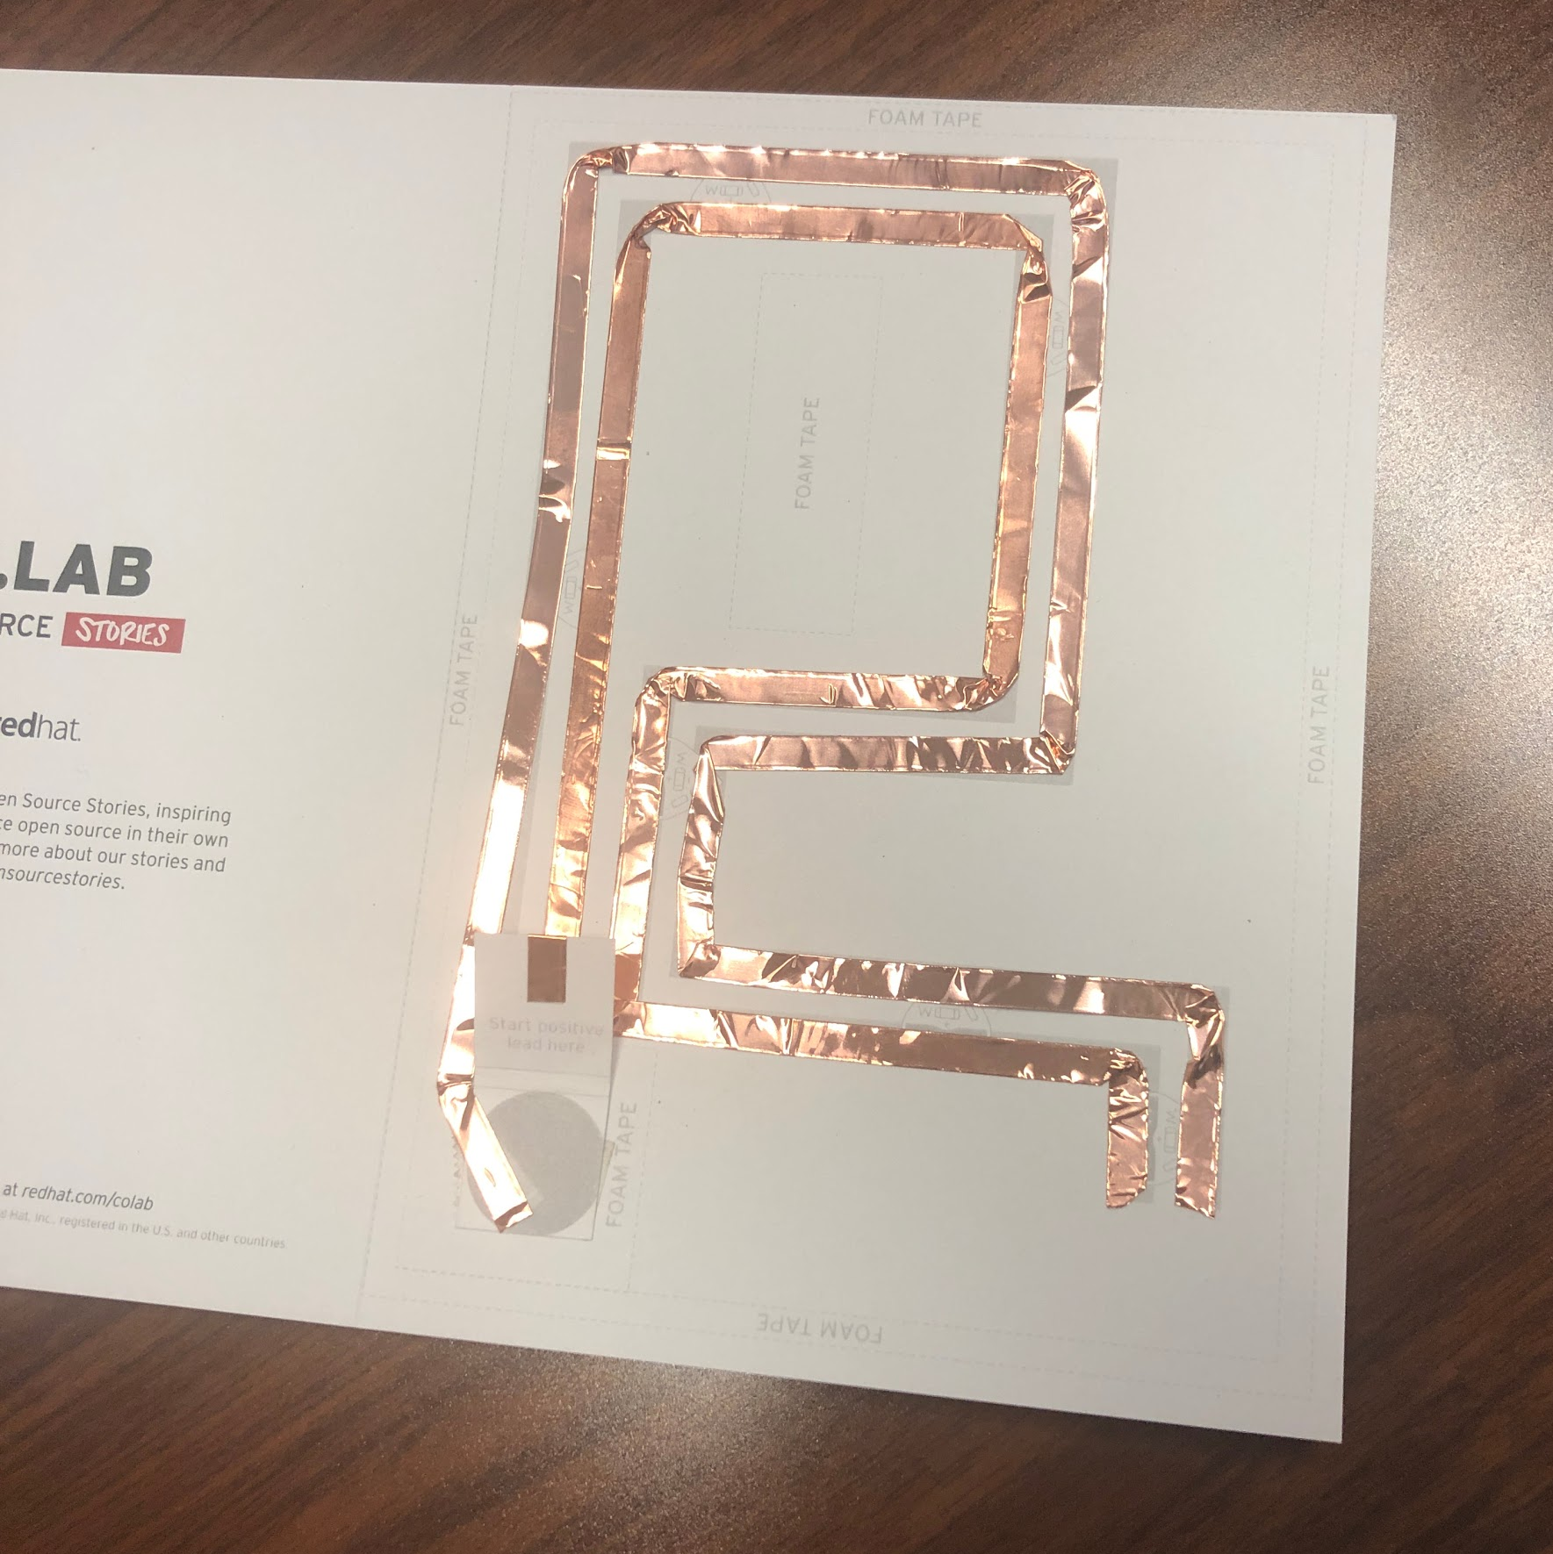
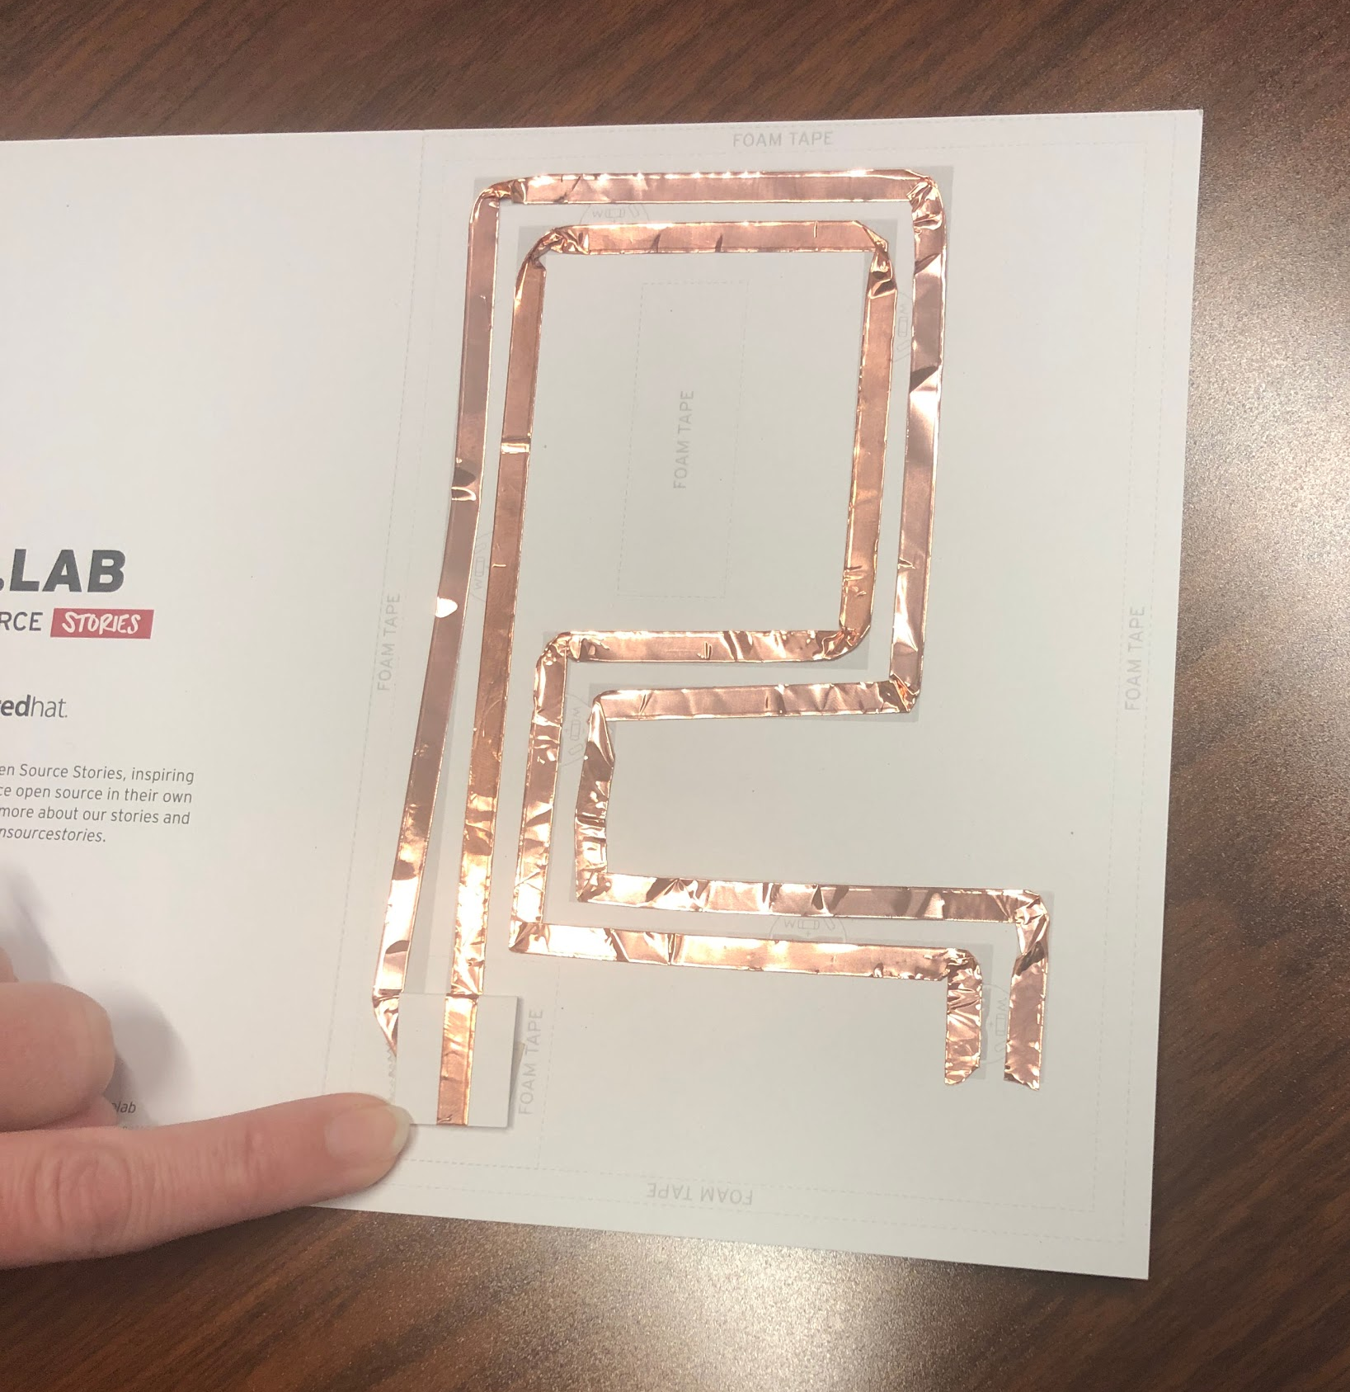

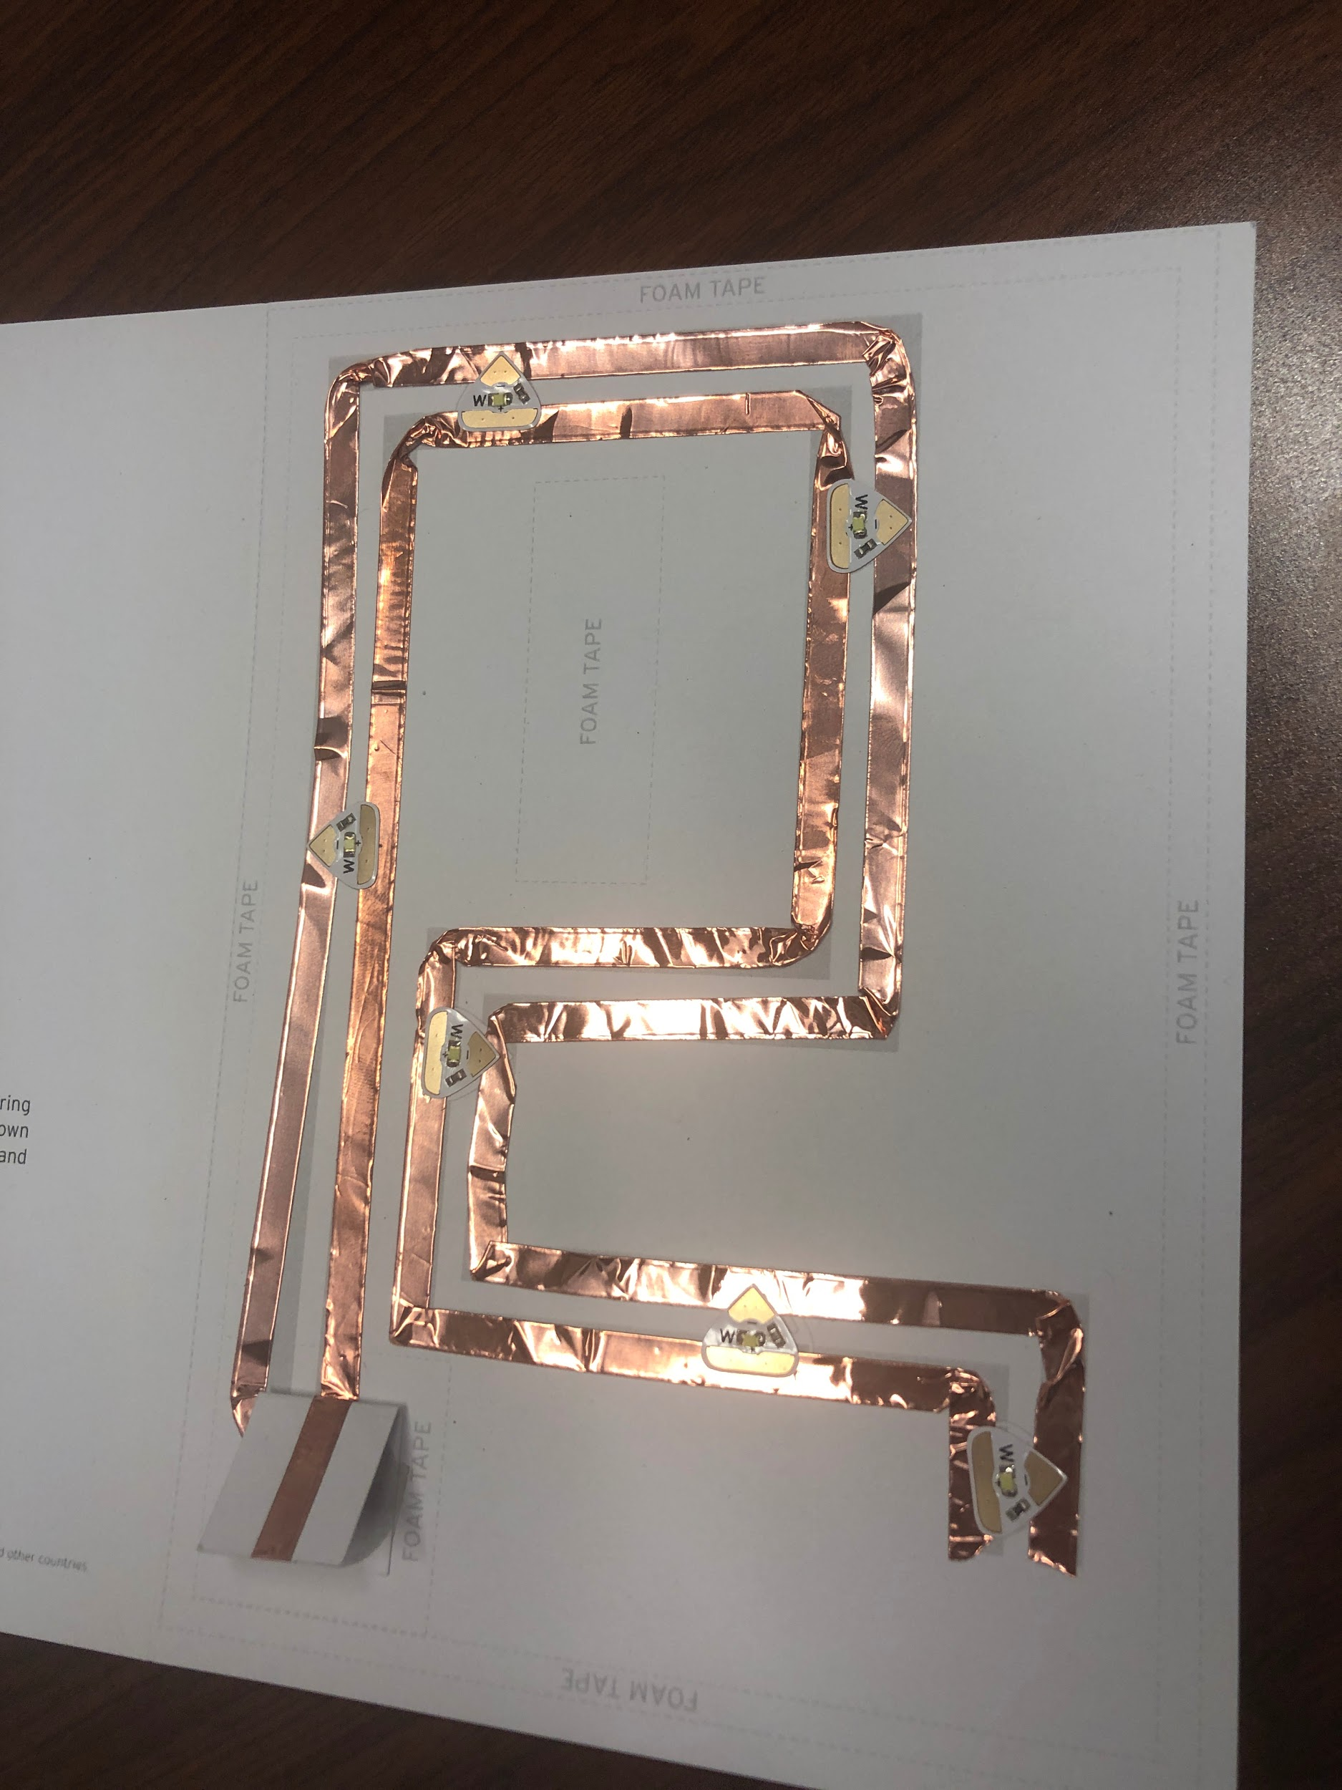

Position the LEDs
- Using the illustration, adhere the LED stickers along the
circuit.
- Ensure that the positive and negative sides of the LED’s
Are aligned with the positive and negative leads.
- Applaud yourself. You just built a circuit.

Test your circuit
- Position the negative side of the coin cell battery on the diagram, under the battery flap.
- Press the flap closed, and watch your LEDs light up.
*LEDs not lighting up? Try the troubleshooting steps listed at the end.

Build the support
- Using the .25” wide mounting tape, follow the illustrations to create a border around the edge of the card base. Once the border is created, remove the protective film. Repeat this step to create a second layer of tape stacked directly on top of the first.
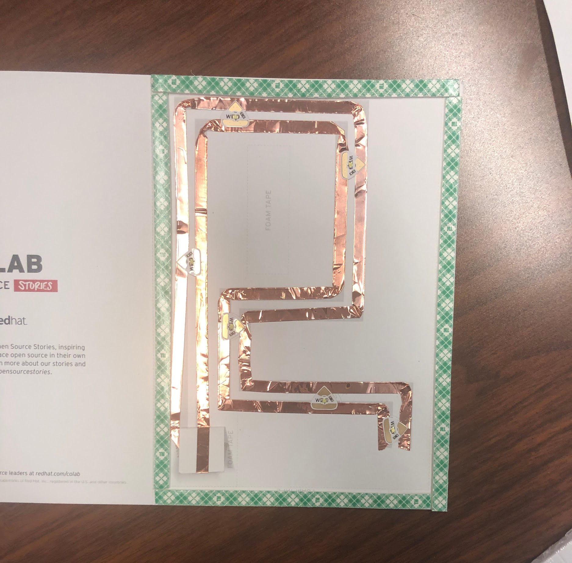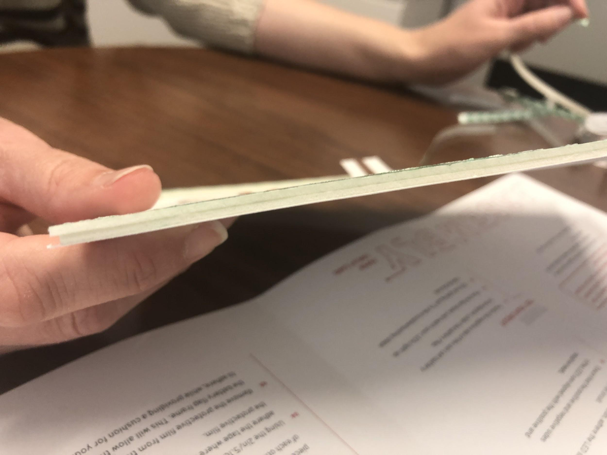

- Using the .25” wide mounting tape, follow the illustrations to make a frame around the battery flap. Once the border is created, remove the protective film. Repeat this step to create a second layer of tape stacked directly on top of the first.
  - Remove the protective film on the top and bottom pieces of the battery flap frame ONLY. Create a third layer of tape on the top and bottom pieces ONLY. You should have three layers stacked on top of each other for the top and bottom only. This extra support ensures that the battery is activated only when you press the button.

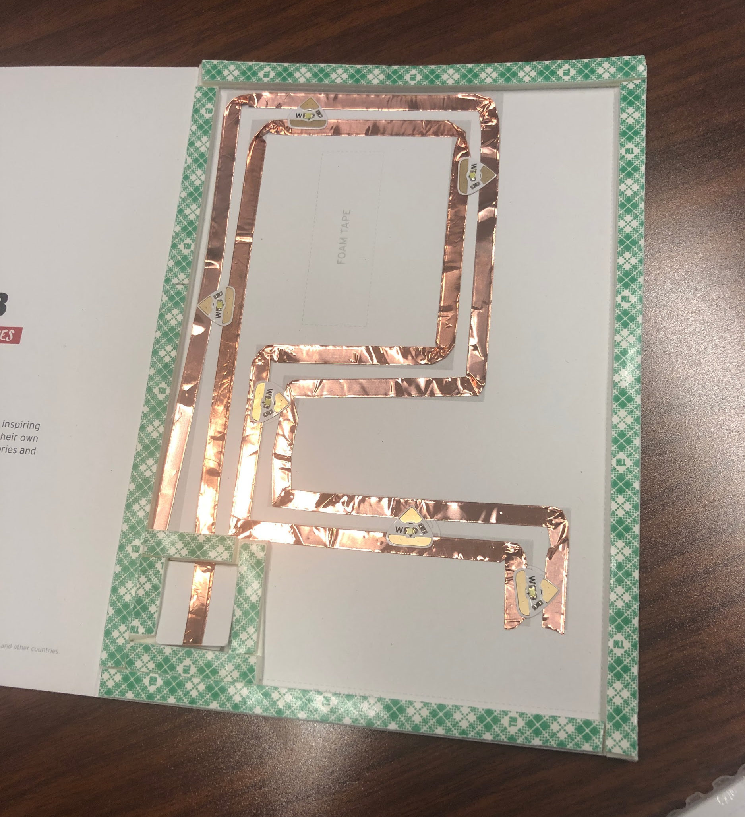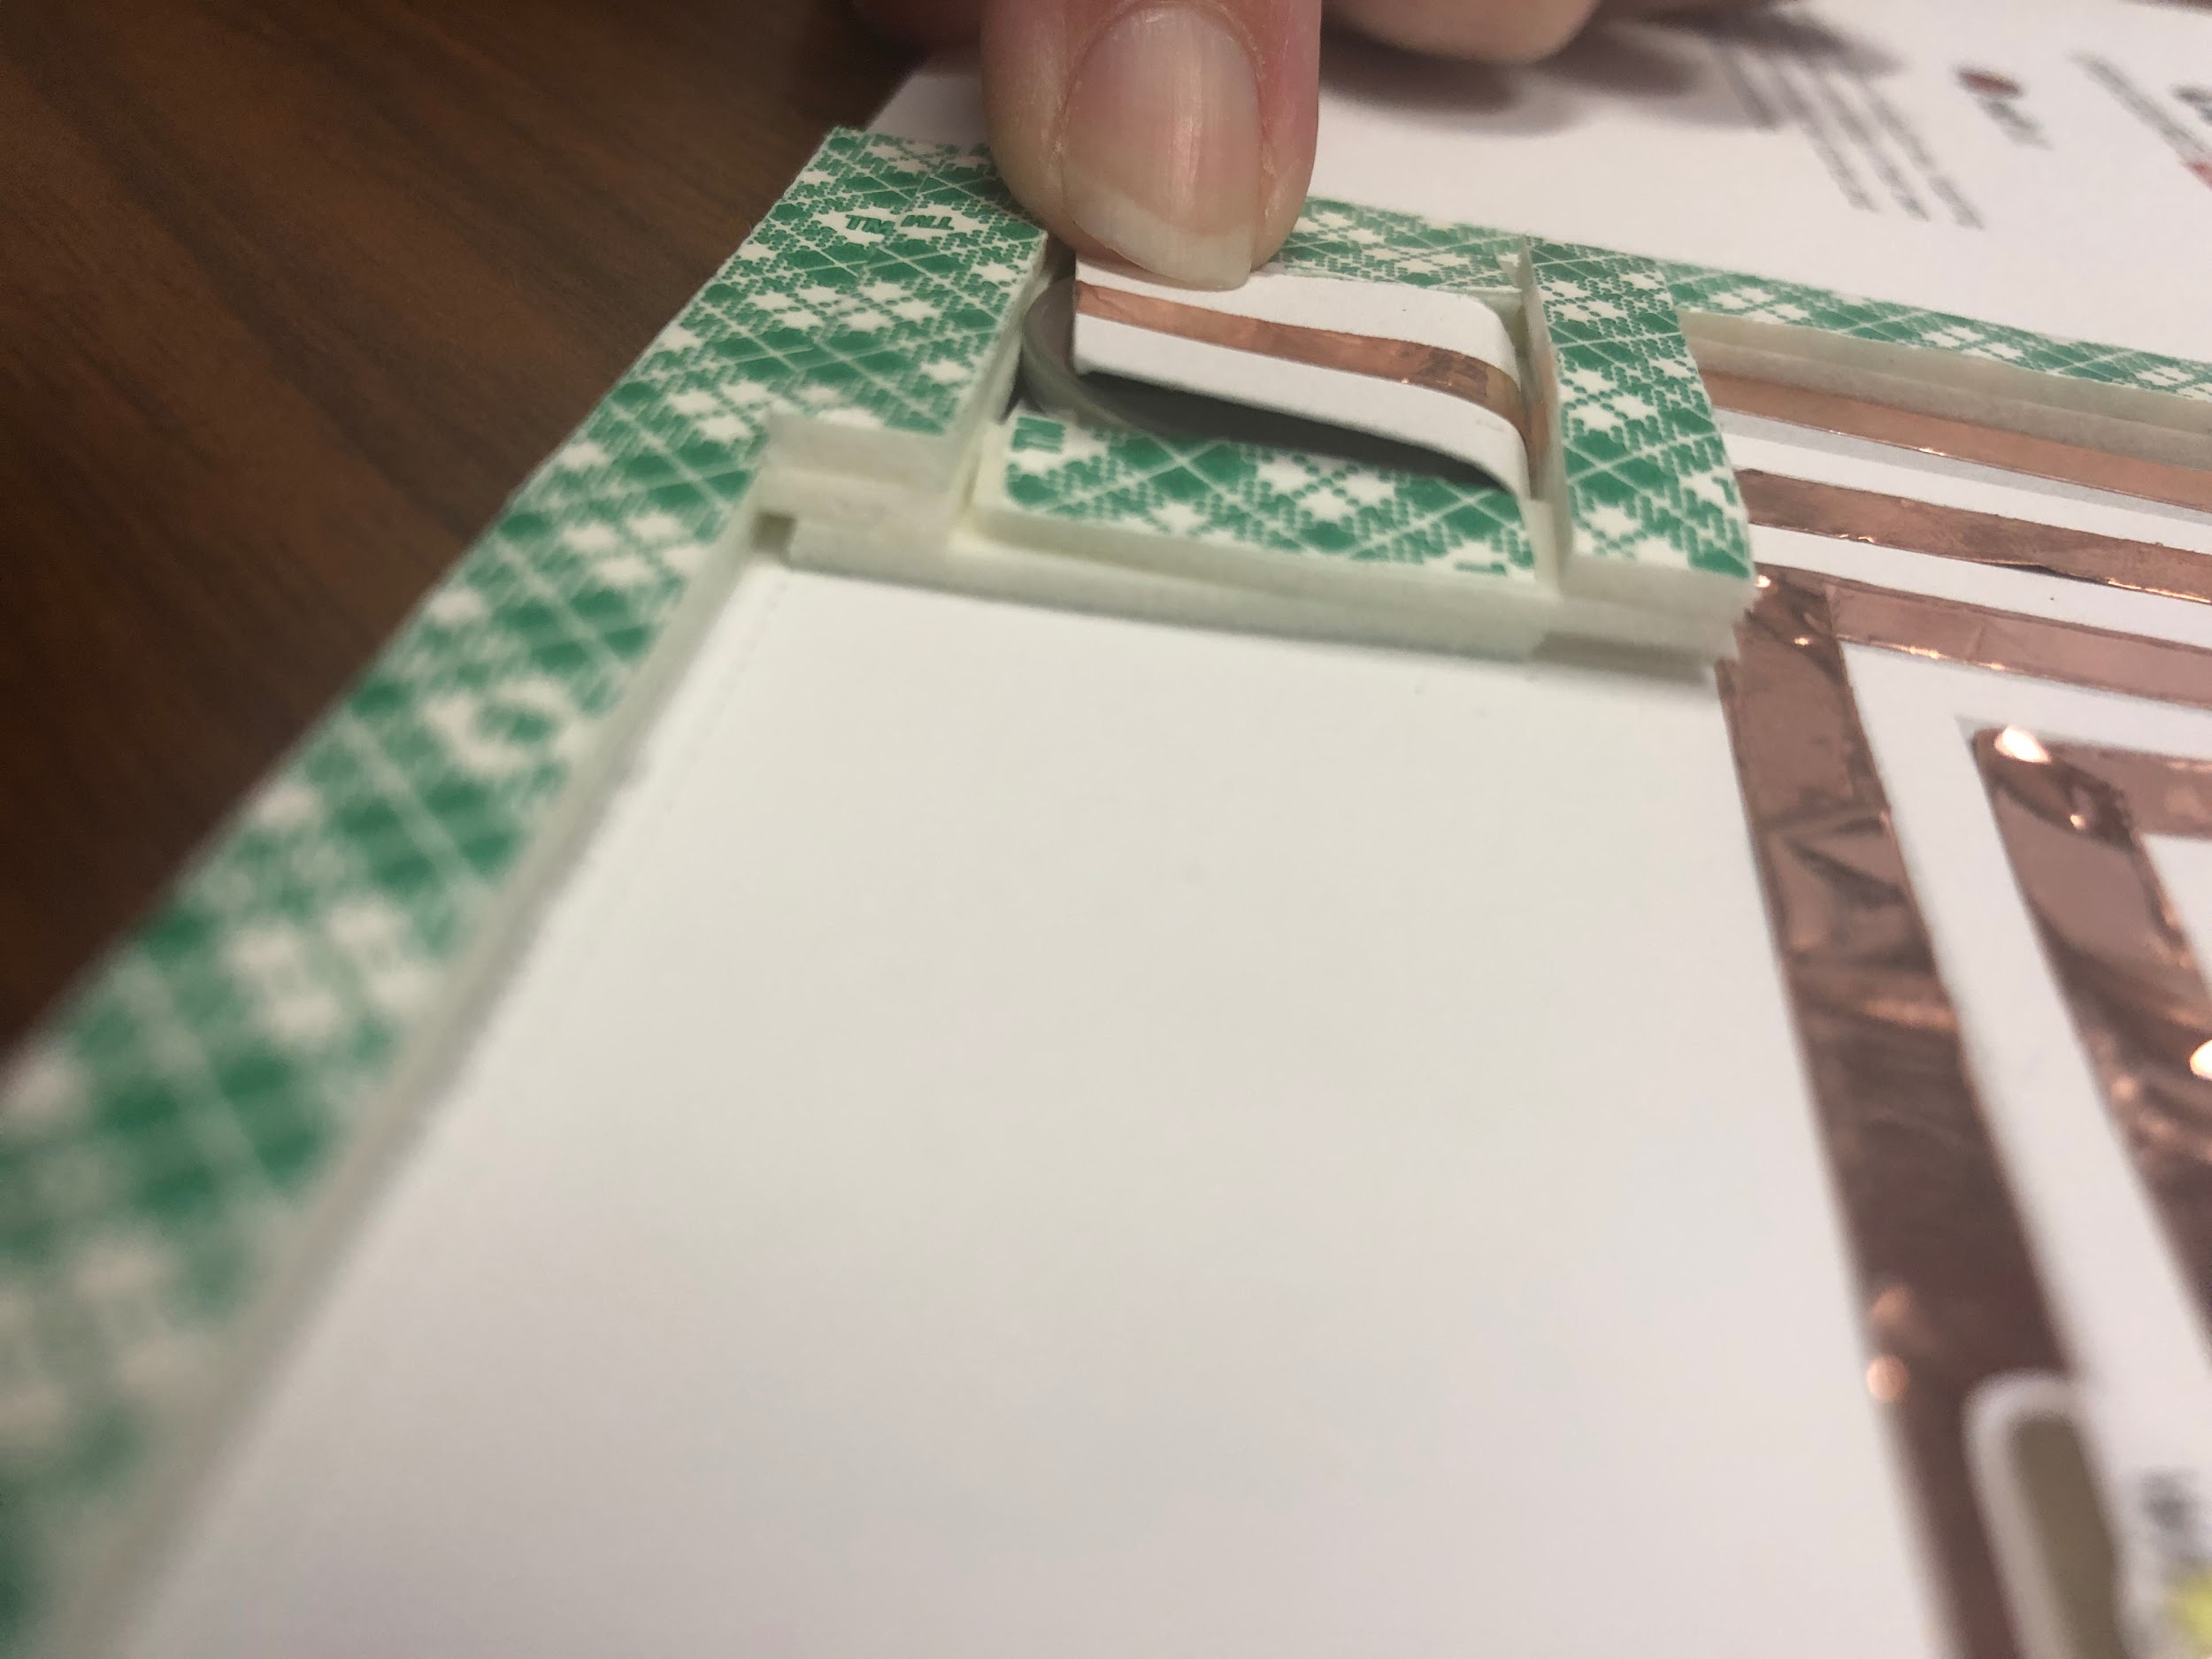

- Using the 2 ” strip of 1” wide mounting tape, adhere the tape where indicated on the illustration. Remove the protective film.
- Remove the protective film from the card border, NOT the battery flap frame. This will allow the overlay sheet to adhere, while providing a cushion for your battery.
- Insert your battery into the battery frame.
- Double check that your battery and LEDs are still working.
- Choose your design and adhere the overlay sheet to the card base and support system you just built.
- Test again that your LEDs light up.
- Fold the card. The inside is blank for your own message and the back side has the Red Hat CO.LAB logo on it.
- High five your neighbor. You just built an electronic card!
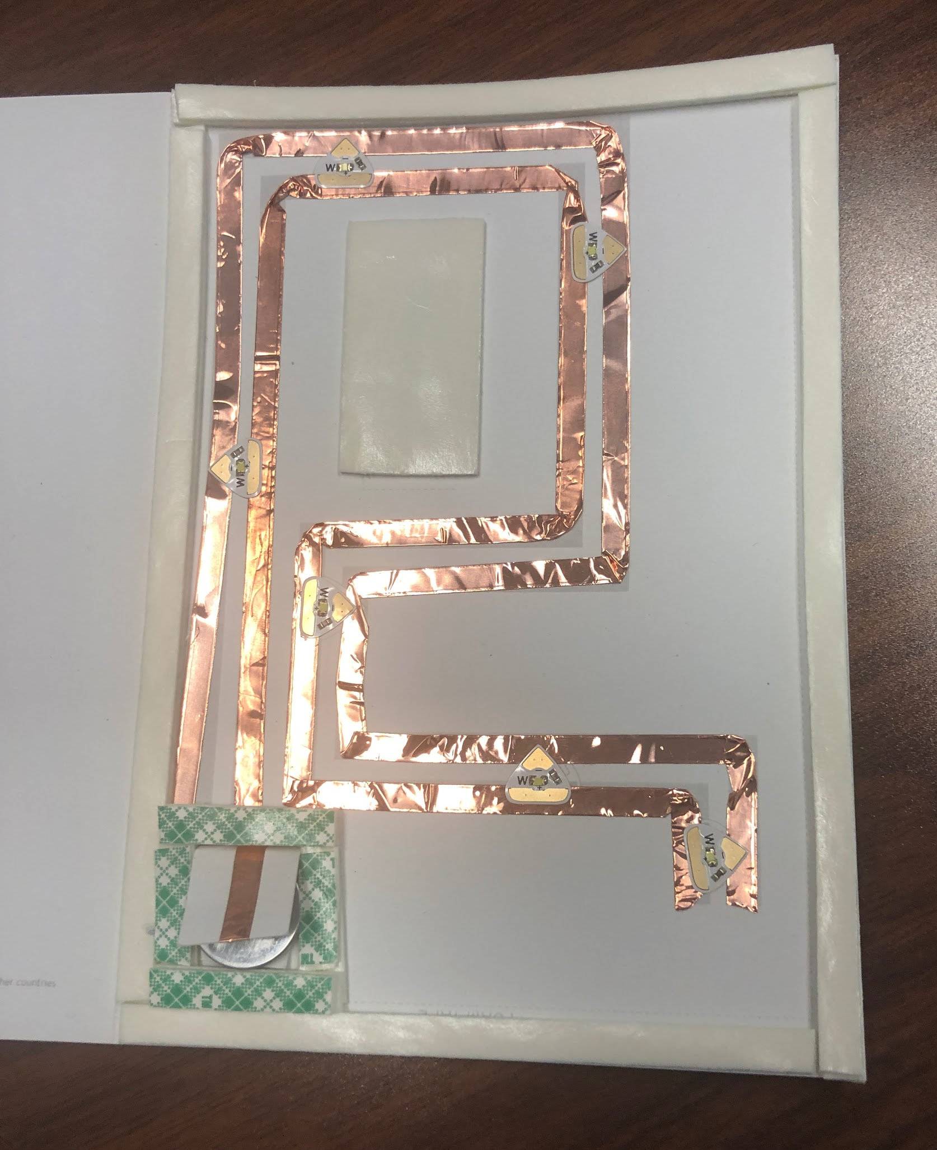

NOTE: If you decide to mail this card, please check your local postal regulations. There may be restrictions on weight and the lithium battery inside your card.

Learn more about our stories and activations at redhat.com/opensourcestories.

